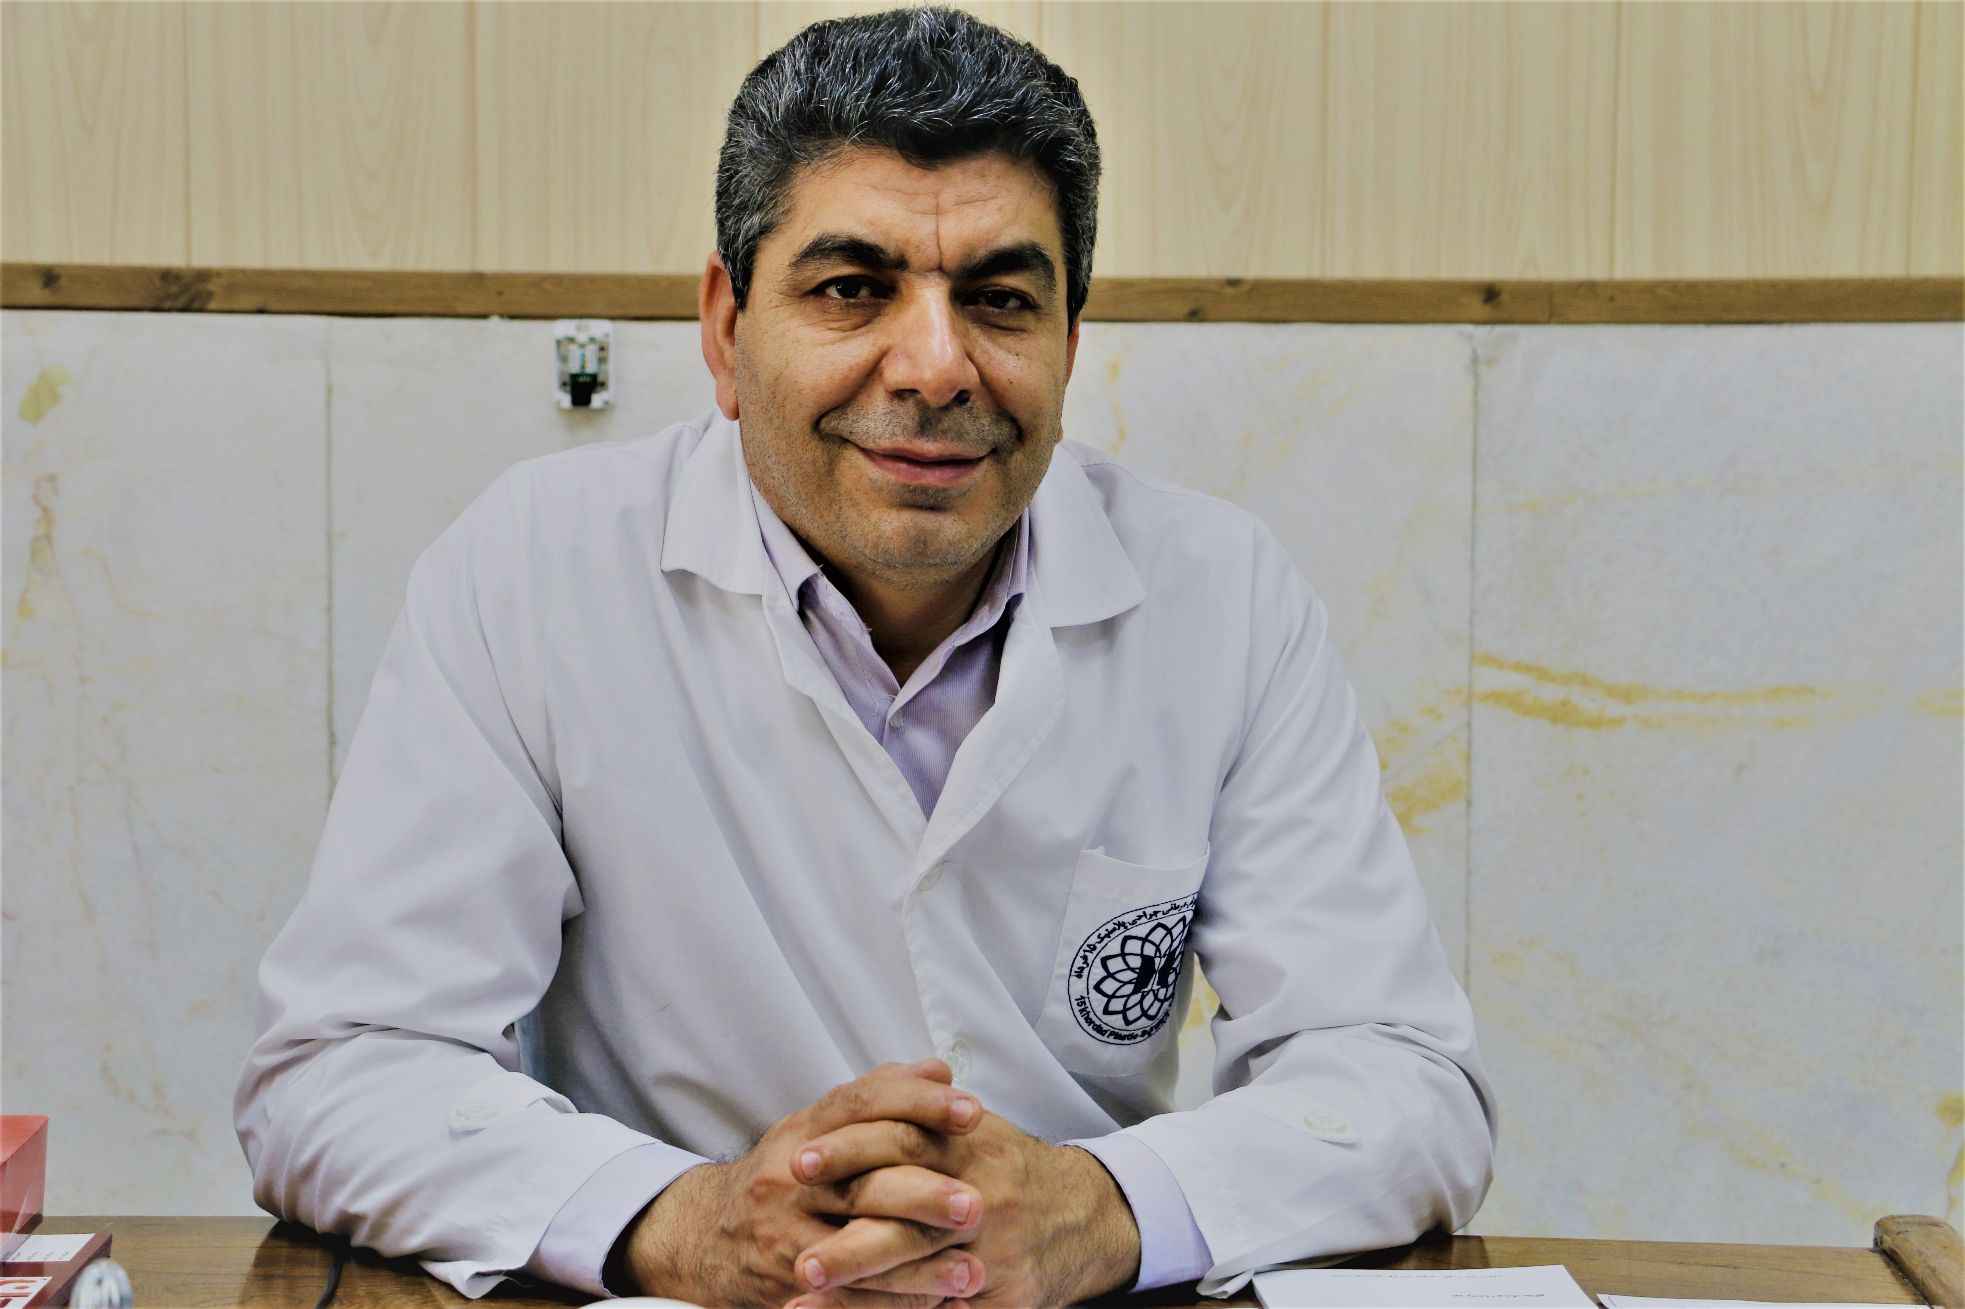 |  |  |  | Name: Abdolreza  Family Name : Rouientan

Brith date : 1967

Brith place : Kouhdasht

Education
Medical Degree , Medical, Isfahan University of Medical Sciences,
Isfahan, 1998

General Surgery , Tehran University of Medical Sciences, Tehran, 2007

Board Certified in Plastic & reconstructive Surgery, Shahid Beheshti University of Medical Sciences, Tehran, 2011

ACADEMIC POSITIONS

Associate professor of Plastic and Reconstructive Surgery , Shahid Beheshti University of Medical sciences (SBMU)

The head of burn department of 15 Khordad Hospital , 2013

The head of the clinic and emergency department of 15 Khordad Hospital from 2013 till now

 |  | 15 Khordad university medical center, Azodi street,Karimkhan Blv. Tehran – Iran
 |  | 00982188902155-9
 |  | rouientan@gmail.  com

